**Experiment No .1**

**Title: Design and Simulation of Computer Network**

**Aim:** To design and simulate the working of computer networks

**Objective:**

1. List the requirements of the organization
2. Prepare the detailed network diagram on paper
3. Translate the network diagram into software form using Cisco Packet Tracer
4. Configure the different parameters of computers
5. Configure the different parameters of interconnecting devices like switch, router
6. Simulate the working of computer network
7. Observe the different packets and its formats

**Theory:**

**There are three different types of components of any computer network.**

**A ] Node**

A network node is a connection point in a communications network. Each node is an endpoint for data transmissions or redistribution. Nodes have either a programmed or engineered capability to recognize, process and forward transmissions to other network nodes. A network node sits at a point in the network where it sends, receives, stores or creates information. It transmits data to communicate with other nodes in the network. In a computer network, nodes can be physical networked devices, such as modems, PCs and printers. These devices recognize transmissions from other nodes and forward them to other nodes. A node checks for identification, such as an IP address, to grant access to the node.

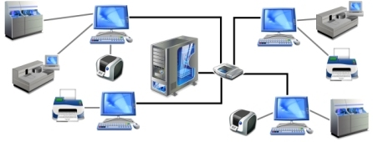

**B ] Connecting Component**

**1. Hub**

Hubs connect multiple computer networking devices together. A hub also acts as a repeater in that it amplifies signals that deteriorate after traveling long distances over connecting cables. A hub is the simplest in the family of network connecting devices because it connects LAN components with identical protocols. Hubs do not perform packet filtering or addressing functions; they just send data packets to all connected devices. Hubs operate at the Physical layer of the Open Systems Interconnection (OSI) model. There are two types of hubs: simple and multiple ports.

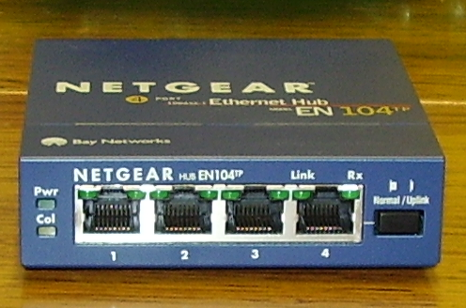

**2. Switch**

Switches generally have a more intelligent role than hubs. A switch is a multiport device that improves network efficiency. The switch maintains limited routing information about nodes in the internal network, and it allows connections to systems like hubs or routers. Strands of LANs are usually connected using switches. Generally, switches can read the hardware addresses of incoming packets to transmit them to the appropriate destination.

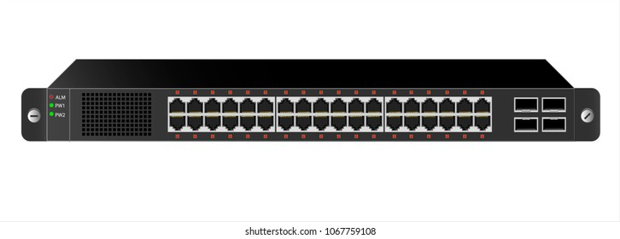

**3. Router**

Routers help transmit packets to their destinations by charting a path through the sea of interconnected networking devices using different network topologies. Routers are intelligent devices, and they store information about the networks they’re connected to. Most routers can be configured to operate as packet-filtering firewalls.

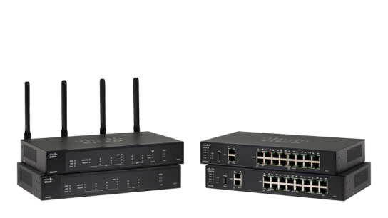

**4. Bridge**

Bridges are used to connect two or more hosts or network segments together. The basic role of bridges in network architecture is storing and forwarding frames between the different segments that the bridge connects. They use hardware Media Access Control (MAC) addresses for transferring frames. By looking at the MAC address of the devices connected to each segment, bridges can forward the data or block it from crossing. Bridges can also be used to connect two physical LANs into a larger logical LAN.

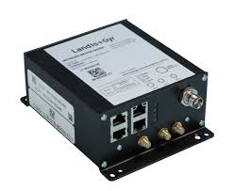

**5. Gateway**

Gateways normally work at the Transport and Session layers of the OSI model. At the Transport layer and above, there are numerous protocols and standards from different vendors; gateways are used to deal with them. Gateways provide translation between networking technologies such as Open System Interconnection (OSI) and Transmission Control Protocol/Internet Protocol (TCP/IP). Because of this, gateways connect two or more autonomous networks, each with its own routing algorithms, protocols, topology, domain name service, and network administration procedures and policies.

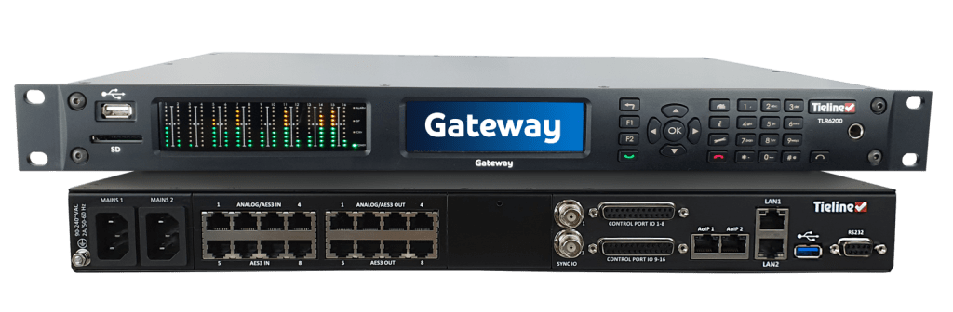

**6. Modem**

Modems (modulators-demodulators) are used to transmit digital signals over analog telephone lines. Thus, digital signals are converted by the modem into analog signals of different frequencies and transmitted to a modem at the receiving location. The receiving modem performs the reverse transformation and provides a digital output to a device connected to a modem, usually a computer.

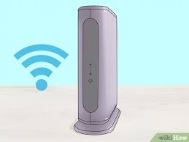

**7. Repeater**

A repeater is an electronic device that amplifies the signal it receives. You can think of repeater as a device which receives a signal and retransmits it at a higher level or higher power so that the signal can cover longer distances, more than 100 meters for standard LAN cables. Repeaters work on the Physical layer.

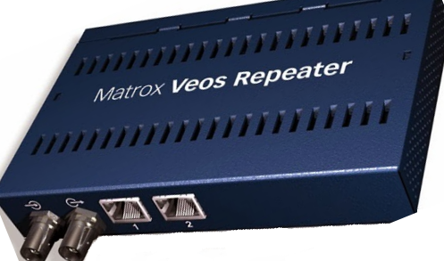

**C ] Transmission Media**

**Guided Media**

It is defined as the physical medium through which the signals are transmitted. It is also known as Bounded media.

**Types of Guided media:**

**Twisted pair:**

Twisted pair is a physical media made up of a pair of cables twisted with each other. A twisted pair cable is cheap as compared to other transmission media. Installation of the twisted pair cable is easy, and it is a lightweight cable. The frequency range for twisted pair cable is from 0 to 3.5 KHz. A twisted pair consists of two insulated copper wires arranged in a regular spiral pattern. The degree of reduction in noise interference is determined by the number of turns per foot. Increasing the number of turns per foot decreases noise interference.

**Types of Twisted pair:**

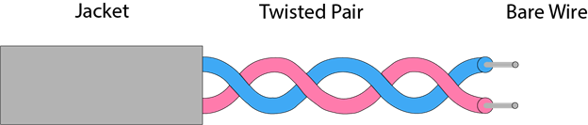

**Unshielded Twisted Pair:**

An unshielded twisted pair is widely used in telecommunication. Following are the categories of the unshielded twisted pair cable:

Category 1: Category 1 is used for telephone lines that have low-speed data.

Category 2: It can support upto 4Mbps.

Category 3: It can support upto 16Mbps.

Category 4: It can support upto 20Mbps.

Therefore, it can be used for long-distance communication.

Category 5: It can support upto 200Mbps.

**Advantages of Unshielded Twisted Pair:**

* It is cheap.
* Installation of the unshielded twisted pair is easy.
* It can be used for high-speed LAN.

**Disadvantage:**

* This cable can only be used for shorter distances because of attenuation.
* Shielded Twisted Pair
* A shielded twisted pair is a cable that contains the mesh surrounding the wire that allows the higher transmission rate.

**Characteristics of Shielded Twisted Pair:**

* The cost of the shielded twisted pair cable is not very high and not very low.
* An installation of STP is easy.
* It has higher capacity as compared to unshielded twisted pair cable.
* It has a higher attenuation.
* It is shielded that provides the higher data transmission rate.

**Disadvantages**

* It is more expensive as compared to UTP and coaxial cable.
* It has a higher attenuation rate.

**Coaxial Cable**

Coaxial cable is very commonly used transmission media, for example, TV wire is usually a coaxial cable. The name of the cable is coaxial as it contains two conductors parallel to each other. It has a higher frequency as compared to Twisted pair cable. The inner conductor of the coaxial cable is made up of copper, and the outer conductor is made up of copper mesh. The middle core is made up of non-conductive cover that separates the inner conductor from the outer conductor.

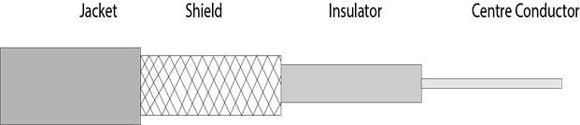

The middle core is responsible for the data transferring whereas the copper mesh prevents from the EMI (Electromagnetic interference).

**Coaxial cable is of two types:**

* Baseband transmission: It is defined as the process of transmitting a single signal at high speed.
* Broadband transmission: It is defined as the process of transmitting multiple signals simultaneously.

**Advantages of Coaxial cable:**

* The data can be transmitted at high speed.
* It has better shielding as compared to twisted pair cable.
* It provides higher bandwidth.

**Disadvantages of Coaxial cable:**

* It is more expensive as compared to twisted pair cable.
* If any fault occurs in the cable causes the failure in the entire network.

**Fiber Optic**

Fiber optic cable is a cable that uses electrical signals for communication. Fiber optic is a cable that holds the optical fibers coated in plastic that are used to send the data by pulses of light. The plastic coating protects the optical fibers from heat, cold, electromagnetic interference from other types of wiring. Fiber optics provides faster data transmission than copper wires.

**Basic elements of Fiber optic cable:**

Core: The optical fiber consists of a narrow strand of glass or plastic known as a core. A core is a light transmission area of the fiber. The more the area of the core, the more light will be transmitted into the fiber.

Cladding: The concentric layer of glass is known as cladding. The main functionality of the cladding is to provide the lower refractive index at the core interface as to cause the reflection within the core so that the light waves are transmitted through the fiber.

Jacket: The protective coating consisting of plastic is known as a jacket. The main purpose of a jacket is to preserve the fiber strength, absorb shock and extra fiber protection.

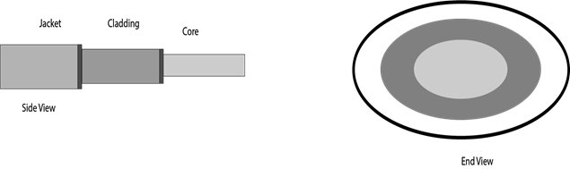

**Following are the advantages of fiber optic cable over copper:**

* Greater Bandwidth: The fibre optic cable provides more bandwidth as compared copper. Therefore, the fibre optic carries more data as compared to copper cable.
* Faster speed: Fibre optic cable carries the data in the form of light. This allows the fibre optic cable to carry the signals at a higher speed.
* Longer distances: The fiber optic cable carries the data at a longer distance as compared to copper cable.
* Better reliability: The fiber optic cable is more reliable than the copper cable as it is immune to any temperature changes while it can cause obstruct in the connectivity of copper cable.
* Thinner and Sturdier: Fiber optic cable is thinner and lighter in weight so it can withstand more pull pressure than copper cable.

**Unguided Media**

An unguided transmission transmits the electromagnetic waves without using any physical medium. Therefore it is also known as wireless transmission. In unguided media, air is the media through which the electromagnetic energy can flow easily. Unguided transmission is broadly classified into three categories:

**Radio waves**

Radio waves are the electromagnetic waves that are transmitted in all the directions of free space.

Radio waves are omnidirectional, i.e., the signals are propagated in all the directions. The range in frequencies of radio waves is from 3 KHz to 1 KHz. In the case of radio waves, the sending and receiving antenna are not aligned, i.e., the wave sent by the sending antenna can be received by any receiving antenna. An example of the radio wave is FM radio.

**Applications of Radio waves:**

* A Radio wave is useful for multicasting when there is one sender and many receivers.
* An FM radio, television, cordless phones are examples of a radio wave.

**Advantages of Radio transmission:**

* Radio transmission is mainly used for wide area networks and mobile cellular phones.
* Radio waves cover a large area, and they can penetrate the walls.
* Radio transmission provides a higher transmission rate.
* Radio waves are the electromagnetic waves that are transmitted in all the directions of free space.
* Radio waves are omnidirectional, i.e., the signals are propagated in all the directions.
* The range in frequencies of radio waves is from 3 KHz to 1 KHz.

In the case of radio waves, the sending and receiving antenna are not aligned, i.e., the wave sent by the sending antenna can be received by any receiving antenna. An example of the radio wave is FM radio.

**Applications of Radio waves:**

* A Radio wave is useful for multicasting when there is one sender and many receivers.
* An FM radio, television, cordless phones are examples of a radio wave.
* Advantages of Radio transmission:
* Radio transmission is mainly used for wide area networks and mobile cellular phones.
* Radio waves cover a large area, and they can penetrate the walls.
* Radio transmission provides a higher transmission rate.

**Microwaves**

Microwaves are of two types:

* **Terrestrial microwave**
* **Satellite microwave communication.**

**Terrestrial Microwave Transmission**

Terrestrial Microwave transmission is a technology that transmits the focused beam of a radio signal from one ground-based microwave transmission antenna to another. Microwaves are the electromagnetic waves having the frequency in the range from 1GHz to 1000 GHz. Microwaves are unidirectional as the sending and receiving antenna is to be aligned, i.e., the waves sent by the sending antenna are narrowly focused. In this case, antennas are mounted on the towers to send a beam to another antenna which is km away. It works on the line of sight transmission, i.e., the antennas mounted on the towers are the direct sight of each other.

**Characteristics of Microwave:**

* Frequency range: The frequency range of terrestrial microwave is from 4-6 GHz to 21-23 GHz.
* Bandwidth: It supports the bandwidth from 1 to 10 Mbps.
* Short distance: It is inexpensive for short distance.
* Long distance: It is expensive as it requires a higher tower for a longer distance.
* Attenuation: Attenuation means loss of signal. It is affected by environmental conditions and antenna size.

**Advantages of Microwave:**

* Microwave transmission is cheaper than using cables.
* It is free from land acquisition as it does not require any land for the installation of cables.
* Microwave transmission provides an easy communication in terrains as the installation of cable in terrain is quite a difficult task.
* Communication over oceans can be achieved by using microwave transmission.

**Disadvantages of Microwave transmission:**

* Eavesdropping: An eavesdropping creates insecure communication. Any malicious user can catch the signal in the air by using its own antenna.
* Out of phase signal: A signal can be moved out of phase by using microwave transmission.
* Susceptible to weather condition: A microwave transmission is susceptible to weather condition. This means that any environmental change such as rain, wind can distort the signal.
* Bandwidth limited: Allocation of bandwidth is limited in the case of microwave transmission.

**Satellite Microwave Communication**

A satellite is a physical object that revolves around the earth at a known height. Satellite communication is more reliable nowadays as it offers more flexibility than cable and fiber optic systems. We can communicate with any point on the globe by using satellite communication.

**How Does Satellite work?**

The satellite accepts the signal that is transmitted from the earth station, and it amplifies the signal. The amplified signal is retransmitted to another earth station.

**Advantages of Satellite Microwave Communication:**

* The coverage area of a satellite microwave is more than the terrestrial microwave.
* The transmission cost of the satellite is independent of the distance from the centre of the coverage area.
* Satellite communication is used in mobile and wireless communication applications.
* It is easy to install.
* It is used in a wide variety of applications such as weather forecasting, radio/TV signal broadcasting, mobile communication, etc.

**Disadvantages of Satellite Microwave Communication:**

* Satellite designing and development requires more time and higher cost.
* The Satellite needs to be monitored and controlled on regular periods so that it remains in orbit.
* The life of the satellite is about 12-15 years. Due to this reason, another launch of the satellite has to be planned before it becomes non-functional.

**Infrared**

An infrared transmission is a wireless technology used for communication over short ranges. The frequency of the infrared in the range from 300 GHz to 400 THz. It is used for short-range communication such as data transfer between two cell phones, TV remote operation, data transfer between a computer and cell phone resides in the same closed area.

**Characteristics of Infrared:**

* It supports high bandwidth, and hence the data rate will be very high.
* Infrared waves cannot penetrate the walls. Therefore, the infrared communication in one room cannot be interrupted by the nearby rooms.
* An infrared communication provides better security with minimum interference.
* Infrared communication is unreliable outside the building because the sun rays will interfere with the infrared waves.

**Input:** Computer network requirement of KIT’s COE Kolhapur

**Software Tool:** CISCO Packet Tracer

**Guidelines:**

As a Network Engineer we have to first understands the requirements of the organization (client/customer) for which you are designing and developing the computer network.

For Example:

i) Data needs to be transmitted between any two computers in the network

ii) Internet can be accessed from the any computer which is part of the organization (client/customer) computer network.

iii) Need to use latest network hardware and software components

**Along with these requirements some information is provided by the organization (client/customer) as follows:**

KIT’s COE Kolhapur wants to setup secure, efficient, reliable new wired and wireless network in their campus. KIT is currently running 10 different departments in campus along with 2 hostels and 1 central library. It is decided to have 6 different application servers to run different academic applications. Total number of users in KIT campus is approximately 4 thousand. All latest software and hardware is expected to use with all computers.

**A] Department wise Number of computers expected**

Biotech: 20, Civil: 20, Civil and Env: 20, CSE: 240, CSE AI ML: 40

CSE DS: 40, CSE CSBS: 20, Mech: 20, E&TC: 20, ELE: 20,

Boys Hostel: 20, Girls Hostel: 20

**B] Application Servers**

Server 1: MOODLE

Server 2: Contineo

Server 3: MOODLE Exam

Server 4: Virtual Lab

As a Network Engineer we have to interpret the requirements and prepare the network diagram on paper sheet. You can use Pen/Pencil for drawing.

For translating the network diagram into software form **Cisco Packet Tracer** needs to be installed on your Computer/Laptop irrespective of OS used.

Using the drag and drop facility prepare the network design using packet tracer.

Make use of simulation feature to simulate the working of the computer network which is prepared for the organization.

**Output:** Design of network diagram of KIT Campus Network with simulation